CSTMA Board Meeting Agenda
1/1/2017; 9am-12pm
ADDRESS: South Jason Street and West Exposition Ave, Denver, CO

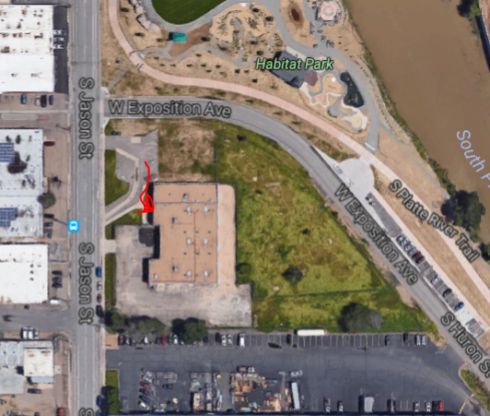

Attendees: Todd Morris, Cody Witham, Steve Shoultz, Chuck Klafka, Jon Kingsley, Gabe Aksamit, John Frankenfeld CSFM, Jeremy Potestio, Abby McNeal, Kellen Stark, Drew Barber
Absent:

- Open Discussion of Board Operation and Goals
- Committee Assignment
  - Newsletter
    - Chair: John Frankenfeld
    - Others:
  - Networking Night
    - Chair:
    - Others:
  - Spring Seminar
    - Chair:
    - Others:

  - LMO
    - Chair:
    - Others
  - Summer Seminar
    - Chair:
    - Others
  - Awards / Scholarships
    - Chair: Cody W.
    - Others:
  - Social Networking
    - Chair:
- Rocky Mountain Halftime
  - Submission Due Dates
    - Spring:
    - Summer:
    - Fall:
    - Winter
- Vendor Sponsorship List
  - Assign Contacts
- Networking Night
  - Infinity Park or Elsewhere
    - Dates:
- Spring Seminar
  - Folsom Field, 5/17/2017
  - Contact Info
- LMO
    - Location, Date
- Summer Seminar
  - Partner with CPRA
  - Contact Info
- Scholarships / Awards
  - 2016
    - Josh Dejong: Field Of Year
    - Benny Paiz and Elliot Thorpe: STMA Giveaway
- Other Business
- Next Meeting
  - Location, Date

